EXPLORING STUDENT’S VIEWS ON JOHN BROWN UNIVERISTY ATHLETICS

Prepared for:
Roby Daugherty, Director of John Brown University Athletics

Prepared by:
Jose Emilio Almanza Carrizo

Soderquist College of Business, John Brown University
Marketing Research (MKT-4113)
Dr. Linda Vytlacil
December 5, 2023

Table of Contents

Executive Summary.................................................................................................. 4
Introduction............................................................................................................... 5
Research Objectives.................................................................................................. 7
Methods..................................................................................................................... 10
Results and Findings................................................................................................. 12
Limitations............................................................................................................... 19
Managerial Recommendations................................................................................ 21
References............................................................................................................... 23
Appendices............................................................................................................. 24

Figures and Tables
Table 1- Gender Distribution …………………………………………………….. 14
Table 2- Class Distribution ………………………………………………………… . 14
Figure 1- IRB Approval…………………………………………………………….. 24
Figure 2- Research Instrument……………………………………………………. 25
Figure 3- Invitational Email………………………………………………………. 25

Executive Summary
This study investigates how to increase student engagement with John Brown University (JBU) Athletics, specifically among Traditional Undergraduate (TUG) students. Trying to improve student’s engagement with the Athletics program. The study sought to better understand Traditional Undergraduate (TUG) students' impressions of JBU athletics, the factors influencing their game attendance, the relationship between player attitudes and program support, and the effectiveness of promotions and incentives. Although variations occurred throughout data collection, hypotheses were developed to guide the quantitative study. To collect data from TUG students, a survey methodology using Microsoft Forms was used. With a sample size of 110 replies, strict ethical considerations were maintained. To test hypotheses and examine demographic differences, statistical techniques such as paired sample t-tests, independent sample t-tests, and one-way ANOVA were used. While hypothesis testing was difficult due to survey structure limitations, significant insights were acquired. Food incentives, team performance, and knowledge of the sport all revealed as important contributors. Gender and class disparities in attitudes toward performance impact were discovered. Despite its flaws, the study provides a platform for future, more focused inquiries. Further research is needed to determine the precise mechanisms by which food incentives, team performance, and knowledge of the sport influence attendance decisions. Positive connections between athletes and students can improve the whole experience by encouraging active engagement and establishing a feeling of community.

Introduction
Active student participation in athletics at John Brown University (JBU) has numerous advantages for both individual students and the institution. In the setting of John Brown University (JBU), where there is no direct money from sporting event ticket sales, the benefits of encouraging active student involvement in athletics stretch across multiple dimensions that contribute to the institution's overall vitality and success. The absence of ticket income does not decrease the need of building a thriving campus sports culture. The good environment created by interested students attending games helps to a vibrant campus culture, generating a sense of community and pride among the student body. This sense of connection and shared experiences can lead to enhanced student happiness, which is an important aspect in retention and the university's overall performance. To begin with, a thriving sports culture contributes greatly to the development of a strong sense of community among TUG students. Furthermore, the prominence and success of athletic teams can be effective marketing and promotion tools for the university, drawing new students and building a positive public image. Vibrant sports culture further boosts JBU's marketability, enticing not only potential students but also sponsors and contributors keen to be associated with a successful and energetic college. A strong athletic program's positive public image can also contribute to increased visibility and media coverage.
This exposure not only attracts new students, but also business sponsors and partners who want to link their brand with a strong educational institution. In essence, TUG students' active participation in athletics is more than just a cultural or recreational feature of university life; it is a strategic economic investment with the potential to improve JBU's financial sustainability, brand recognition, and alumni support. Alumni relationships, which are typically formed via shared sporting experiences, constitute an important component of fundraising efforts. Alumni who have great recollections of attending games or participating in athletic programs are more likely to have a strong connection to the university (Meer, 2008). This emotional connection can result in significant support in the form of donations, sponsorships, and participation in fundraising activities, providing critical resources for JBU's growth and development.
John Brown University (JBU) Athletic Department faces a problem where they want to increase the attendance and active participation of Traditional Undergraduate (TUG) students in Athletics events, particularly games. This issue is critical for various reasons that go beyond simple attendance counts. This issue is critical for a variety of reasons that go beyond the number of individuals that attend. Great sports culture not only makes the campus more enjoyable; it also brings people together, enhances school spirit, and makes the entire campus feel more positive. Understanding why kids choose to attend games is critical because it helps us understand how students become interested, what they enjoy, and what may be preventing them from participating. Understanding what motivates students to attend games is critical for developing techniques that are relevant to their interests and preferences. It entails investigating the motivations, whether they be a sense of a social connection, or a true passion in the sport. By recognizing these motivators, the Athletic Department can adopt focused initiatives, such as themed events, student promotions, or better spectator experiences, to make games more enticing and entertaining.
Therefore, JBU’s Athletic Department wants to create an environment that matches with the choices and interests of TUG students, not only increase attendance. Understanding what motivates students to attend games and applying measures to increase their participation allows the university to reap benefits that go beyond the immediate aim, favorably impacting campus culture, prospective student recruiting, and long-term alumni engagement.
Research Objectives
The purpose of this research is to find out what Traditional Undergraduate (TUG) students think about John Brown University (JBU) athletics. We want to hear their overall feelings about the athletic program, including what they like and dislike. Next, we'd like to know why kids choose to attend games or why they might choose to skip them. We're also investigating whether how students feel about particular players correlates with how much they support the overall sports program. We also want to test if providing special bargains or rewards can inspire more TUG students to attend games.
Therefore, these are the research objectives:

1- To determine TUG students' perception of JBU athletics overall.

2- To determine reasons why or why not TUG students attend games.

3- To determine if there is a relationship between TUG students' perception of Athletes and their support for the program.

4- To determine if promotions and incentives will increase the attendance of JBU TUG students to sporting activities (games).

5- To determine how the attitudinal information defined from previous statements varies according to gender and class.

The creation of hypotheses is critical in the context of performing a quantitative study for methodically analyzing linkages and impacts within the data. Initially, a set of hypotheses was developed to explore several characteristics of TUG students' participation in JBU athletics.
Initially, the following hypotheses were proposed:

- H1: There is no influence of students' perception of JBU athletics overall on students' decision to attend games.

- H2: There is no relationship between food incentives during games for TUG students and their decision to attend games.

- H3: There is no perception from TUG students that student-athletes receive preferential treatment.

- H4: There is no relationship between TUG students' knowledge of the respective sport that is being played and their decision to attend games.

- H5: There is no association between the athletics team performance and TUG students' desire to attend games.

- H6: There is no relationship between students not being/feeling invited by athletes to games and their desire to attend games.

- H7: There is no difference between student perception of JBU athletes between men and women.

However, it is important to note that during the data collection phase, there was a deviation from the original plan, and some questions necessary for testing these hypotheses were not asked. Therefore, given the mistake where key essential questions were not asked, the research approach must be modified. The oversight in data collecting during this study will serve as a good lesson for future studies. Recognizing the impact on precision, efforts will be made to improve the study process and reduce the margin of error.
However, to continue and make the most of the current data, new hypotheses that correspond with the questions that were effectively addressed must be developed. While the absence of specific questions during data collecting provides a problem and may influence the study's precision, the research is committed to obtaining as many insights as possible from the existing data. Therefore, a new set of hypotheses were created:
- H1: There is no difference in the mean level of agreement between the influence of food incentives on the decision to attend JBU athletics games and the impact of the performance of the JBU athletics team on the desire to attend games.
- H2: There is no difference in the mean level of agreement between the influence of food incentives and the level of knowledge about the rules and dynamics of the sport on the decision to attend JBU athletics games.
- H3: There is no difference in the mean level of agreement between the impact of the performance of the JBU athletics team on the desire to attend games and the impact level of knowledge about the rules and dynamics of the sport on the decision to attend JBU athletics games.
- H4: There is no difference in the average level of agreement in knowledge of sports rules influencing the decision to attend games among genders.
- H5: There is no difference in the average level of agreement in food incentives influencing the decision to attend games among classes.
- H6: There is no difference in the average level of agreement in performance influencing the decision to attend games among gender.
- H7: There is no difference in the average level of agreement in performance influencing the decision to attend games among classes.

Methods
For this quantitative study, a survey was chosen as the best research methodology to evaluate the hypotheses, and Microsoft Forms was used as the data gathering platform. The survey, which was rigorously designed to correspond with the research objectives, includes a wide range of TUG students' experiences, including their impressions of student-athletes, satisfaction with the JBU athletics program, and game-attendance experiences. The poll was circulated via email using a random selection technique from a pool of currently enrolled TUG students to ensure a representative sample. This randomized email distribution is crucial for the study's integrity since it eliminates bias and guarantees that replies are representative of the TUG student body as a whole. The emphasis on participant anonymity and secrecy emphasizes the research's ethical considerations, assuring respondents that their replies will be kept confidential and that no personally identifying information would be collected. This strategy is consistent with the study's dedication to ethical research practices and the reliability of its findings.
Potential mistakes in the sample frame, such as nonresponse from specific students or unintended email address duplication, are concerns that I must address immediately. To address these concerns, I intend to oversample by mailing the survey to more people than the minimum sample size. This method includes a buffer to account for any potential nonresponses or duplicates in the dataset. Given the possibility of sample frame errors, purposeful oversampling ensures a more robust and reliable representation of the target population. The study's implementation of this precautionary step attempts to reduce the impact of any errors on the accuracy and validity of the collected data, thereby improving the overall quality of the research conclusions.
To determine the proper sample size, I used a calculated strategy, using the formula n= ((1.96) ^2 * (0.8) ^2) / (0.15) ^2​, I computed that I needed a required sample size (n) of approximately 110 responses. However, recognizing the necessity for an adjustment factor, I went on to compute the adjustment factor formula: 110 * sqrt ((1297-110) / (1297-1)), which resulted in 104.608. Therefore, the calculated sample size of 105 is the adequate for the investigation.
The survey instrument, which is given using Microsoft Forms, has three multiple-choice questions with a scale for measuring agreement and two open-ended questions to promote thorough responses. Furthermore, demographic questions such as gender and class standing provide essential information within the unique community of JBU TUG students. The Institutional Review Board (IRB) department thoroughly reviewed the survey to ensure its adequacy for addressing the viewpoints of JBU students.
My next step after collecting all the responses was to export the data to Excel. This shift is a critical preparation phase that will allow me to efficiently arrange and structure the data. The organized data is required for the smooth integration of R Studio, my preferred analytical tool for testing ideas and collecting valuable insights. I intend to undertake strong statistical analyses, analyze trends within the data, and finally draw relevant findings that directly answer my research objectives by harnessing the capabilities of R Studio. This careful methodology, from survey design to data preparation, demonstrates my dedication to generating important and accurate insights from the data collected.
Reflecting on the process, I realize how important precision is in designing survey questions. I ran into problems after exporting the data and attempting to test the hypotheses due to ambiguities in the survey questions. This conclusion emphasizes the importance of taking a more rigorous approach to developing questions that properly fit with the targeted hypotheses. In the future, I plan to put more effort into improving and clarifying survey inquiries to guarantee they accurately collect the data required for hypothesis testing. This experience has taught me a vital lesson about the importance of precision in survey design to support effective analysis and draw meaningful conclusions from the data obtained.

Results and Findings

As we enter the section on results and findings, our attention will be drawn to the methodical evaluation of data gathered from the finely structured survey and subsequent analyses. We will thoroughly examine the hypotheses, where I hope to identify relevant linkages through hypothesis testing that will lead to a more nuanced understanding of TUG students' perspectives and the determinants impacting their participation with JBU athletics.
Before we begin our investigation, it is critical to recognize the final response rate resulting from the survey data. The Response Rate, computed as 112 out of 1124 respondents, is about 10.06%. This figure represents the percentage of John Brown University TUG students who actively participated in the survey. To be more specific, 112 people responded to the 1124 emails sent. However, to assure the accuracy and reliability of our data, we went through a screening process to discover and keep authentic responses. We selected 110 valid and authentic responses through this screening, which will serve as the foundation for our further studies. Securing 110 complete responses is critical for the study. To attain statistical significance, the first estimate indicated a sample size of 105 responders. However, exceeding this minimum threshold and receiving 110 actual responses adds a layer of resilience to our dataset. This surplus not only ensures that we achieve and surpass the required sample size, but it also allows for a more extensive and trustworthy study of the viewpoints of the targeted demographic.
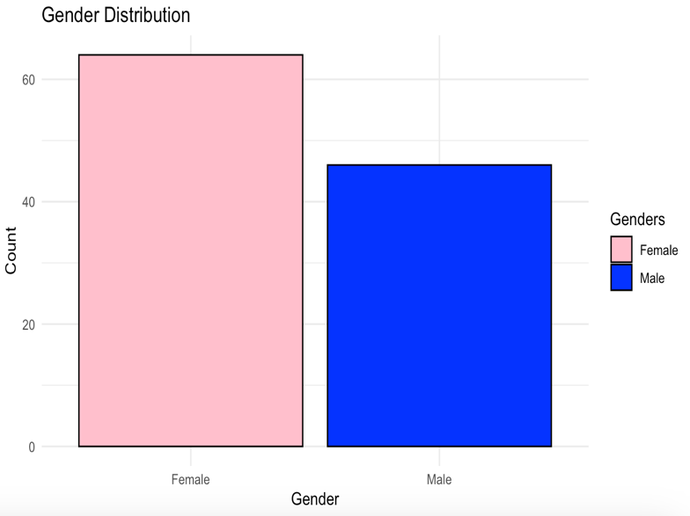
Our investigation will then investigate crucial demographic data from our respondents. Our analysis continues, as shown in Table 1, by investigating critical demographic data from our sample of 110 TUG students at John Brown University. The gender breakdown suggests that 58.2% of respondents identify as female, while 41.8% identify as male. These percentages provide useful insights into the gender dynamics of our survey, allowing for a more nuanced examination of how attitudes and engagement with John Brown University athletics differ between male and female students.
Table 1- Gender Distribution
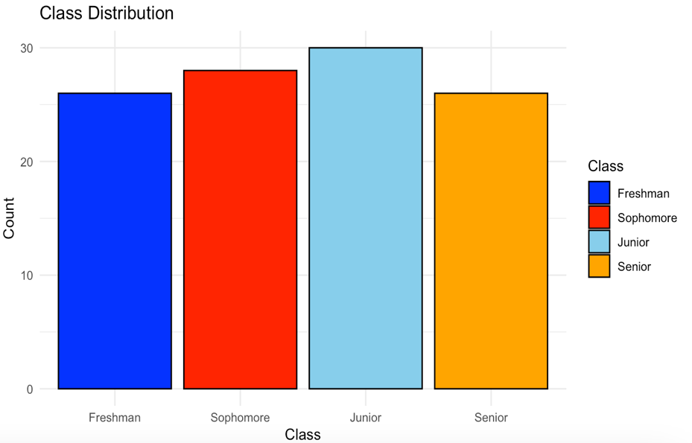
Shifting our focus to Table 2, this table digs into the current class standing of the 110 TUG students at John Brown University. The proportion across academic levels is strikingly illustrated in this table: 23.6% are freshmen, 25.5% are sophomores, 27.3% are juniors, and 23.6% are seniors. This detailed analysis provides a good snapshot of the present class standing distribution at JBU.
Table 2- Class Distribution

Later on we where we were able to test our hypothesis. For this, we used numerous statistical approaches to evaluate the data from our survey in order to test our hypotheses. A paired sample t-test was used to test Hypothesis 1, which proposed that there was no difference in the mean degree of agreement between the influence of food incentives and the impact of the JBU athletics team's performance on game attendance. The results showed a mean difference of 0.1545 and a p-value of 0.2001, so we fail to reject the null hypothesi. However it indicatid that there was no significant difference between the two. In assessing the impact of food incentives and JBU athletics success on attendance decisions, it is clear that respondents in categories 3.9 and 4.0 rely heavily on the Agree part of the 5-point scale. This demonstrates agreement on the impact of food incentives and athletic performance on game attendance decisions. Despite this consensus, the precise methods by which these factors exert their influence remain opaque in our analysis.
For our Hypothesis #2, , another the paired sample t-test showed a mean difference of 0.3727 with a p-value of 0.00448, therefore we fail to reject the null hypothesis showing a significant difference in the level of agreement, which investigated the association between food incentives and knowledge of the sport affecting the decision to attend games. In here we can conlude that incentives have a higher level of agreement with 4.0636 as average response, that will rely on the Agreee section in a 5 point scale, in comparison to a 3.6909 for knowledge of the sport. Despite this agreement, the precise mechanisms by which these factors influence attendance decisions remain unknown.
Moving on to Hypothesis 3, used the same approach of paired sample t-test, which investigated the impact of the JBU athletics team's performance and knowledge about sports rules on game attendance decisions, a paired sample t-test showed a mean difference of 0.2182 and a p-value of 0.04049, therefore we reject this hypothesis signifying a significant difference in agreement levels. However, we lack information to determine how both variables affect the desire to attend games.
For Hypothesis 4, I decided to conduct an independent sample t-test, where we investigated gender differences in understanding of sports rules influencing attendance, the p-value (0.08885) for is greater than 0.05, resulting in a failure to reject the null hypothesis. This shows that there is no statistically significant difference between genders. We can see that there is similar levels of agreement across genders towards the level of knowledge about the sport being played and their decission to attend games, however we lack again information to know how this affects it.
For Hypothesis 5, I decided to conduct a one-way ANNOVA, which investigated class differences in the average level of agreement in food incentives influencing attendance, yielded a p-value of 0.389, which was again greater than 0.05, we fail to reject the null hypothesis meaning that there is no significant different in level of agreement with the statement that food incentives affect the desire to attend games. However, we lack information to determin how this variable affects the desire.
For hypothesis #6 the null hypothesis was intended to determine whether there is no difference in the average level of agreement in performance impacting the decision to attend games between genders The p-value from the independent sample t-test was 0.007577, which is less than the commonly used significance level of 0.05. As a result, we reject the null hypothesis, indicating that there is a statistically significant difference. According to the sample estimations, the mean level of agreement in performance impacting attendance is 3.6875 for females and 4.2174 for males. The higher mean for males indicates that, on average, male students agree with the importance of performance in their decision to attend JBU athletics events more than their female counterparts. This difference is not only statistically significant, but it also suggests a practical significance in gender differences in attitudes and preferences about the influence of performance on attendance.
Finally,we conduct a one-way ANNOVA for hypothesis , the p-value (0.795) for Hypothesis 7, which investigates class inequalities in the impact of performance on attendance, this results in a p-value of (0.795),which is significantly above 0.05. As a result, we fail to reject the null hypothesis, implying that there is no substantial difference across classes. We see various mean degrees of agreement between classes when we examine the sample estimates: Freshman (3.96), Sophomore (3.89), Junior (3.77), and Senior (4.04). Despite the fact that they do not approach statistical significance, these mean values provide subtle insights on the attitudes of students in various classes. Notably, seniors are more likely than juniors to agree that performance influences their decision to attend games. Despite the lack of statistical significance, these findings provide useful qualitative information concerning potential class-related differences in attitudes toward game participation.
When the results of our hypothesis were revealed, it became clear that, despite the introduction of a new set of hypotheses, overcoming the objectives described in this study offered a significant challenge. Instead of correlating with expected outcomes, the data acquired highlighted the need for further investigation and a rethinking of our research strategy. The intrinsic intricacies of the topic matter, combined with the limits of our current research approach, became crystal clear. Our existing theories failed to appropriately cope with the complexities of the research issue, resulting in the study falling short of our clients' expectations.
In pursuit of our initial objective, aimed at gauging TUG students' perception of JBU athletics overall, we encountered a shortfall in our approach. Regrettably, we did not pose the requisite questions to capture a comprehensive understanding of the students' overarching perspective. Concerning the second objective, which aimed to identify the factors influencing TUG students' attendance or non-attendance at games, we encountered a limitation in elucidating the specific reasons behind these decisions. Despite this, our analysis revealed a noteworthy consensus among the tested variables. Notably, food incentives emerged as the top-ranking factor, followed by performance and knowledge of the sport. Regrettably, the study fell short of providing a conclusive understanding of how these variables precisely impact the decision-making process. Concerning the third objective, which sought to investigate the relationship between TUG students' perceptions of athletes and their support for the program, it became clear that a definite hypothesis was absent, and our evaluation was based on an examination of relevant survey questions. Although we were unable to exactly examine the influence of JBU athletics on overall attendance through hypothesis testing, an open-ended question yielded useful insights. Students were asked the following question: "To what extent does the perception of JBU athletics overall influence your decision to attend games?" Words that came up repeatedly in their comments included "good" and "friends." While these qualitative responses may not have the statistical rigor of hypothesis testing, they do provide a qualitative knowledge of the elements that influence students' decisions. The frequent use of words like "good" suggests a positive link, yet the use of "friends" shows a social component that influences attendance decisions. Despite the current study's inability to precisely evaluate these effects through hypothesis testing, the persistent themes of "good" and "friends" in the open-ended replies suggest a promising avenue for further investigation. This prompts an interest in conducting a more targeted poll, specifically designed to quantify JBU athletics' perceived influence on attendance decisions. Concerning the fourth objective, which was to determine whether promotions and incentives would increase JBU TUG students' participation at athletic events, our findings revealed that incentives had the highest level of agreement as a significant factor motivating students to attend games. However, there is a major gap in our understanding since we lack information to determine whether these incentives would boost attendance, given the lack of insights into how incentives particularly affect the willingness to attend. In the context of the fifth objective, which attempted to investigate differences in attitudinal information based on gender and class, was not met. Despite having demographic data at our disposal, our ability to undertake a complete examination of the attitudinal variances across different gender and class categories is hampered by a lack of past valuable information.

Limitations
One of the most noteworthy limitations of this study is the inability to evaluate the original assumptions due to deficiencies in the survey question structure. The lack of questions designed to test the hypotheses has proven to be a serious drawback, impeding the study's capacity to satisfy the client's precise expectations, Mrs. Daugherty. This limitation jeopardizes the study's comprehensiveness, as the inability to directly test the hypotheses may prevent the development of precise insights and decisive findings. The misalignment between the intended research objectives and the realized survey structure jeopardizes not only the alignment with Mrs. Daugherty's expectations, but also the overall robustness and correctness of the study's conclusions. Recognizing and openly admitting this restriction is critical for transparency and providing a clear knowledge of the study's boundaries and potential implications for the results drawn from the data collected. Despite this limitation, efforts will be made to glean useful insights from the available data and make relevant conclusions within the limited scope of the study.
However, despite its limitations, the investigation has revealed previously unknown prospects. The study foreshadows a future possibility by noting the possible benefits of improving the survey questions to correspond with the original hypotheses. This acts as an invitation to investigate the client's initial queries further, implying that the study should be continued with more targeted and refined research objectives. Thus, even within the restrictions of the current iteration, the study prepares the way for a future iteration that offers the potential of more precisely and effectively answering the client's expectations.

Managerial Recommendations

Notably, food incentives, team performance, and understanding of the sport have all been identified as factors influencing TUG students’ participation at JBU athletic events. While acknowledging the importance of these variables on game attendance decisions, the next critical step is to delve into understanding the exact mechanisms at work. As a result, it is advised to undertake targeted testing to discover how these variables influence attendance decisions accurately. This in-depth investigation will throw light on the importance of these aspects and provide actionable recommendations for developing targeted marketing efforts.
Using positive connotations seen in open-ended responses, such as "good" and "friends," provides a systematic method to setting the atmosphere at events. As a result, athletes must project a nice and approachable tone toward pupils. Athletes who act as ambassadors and engage positively with the school body can make a huge contribution to keeping a positive outlook. Friendly interactions can help to establish a sense of community and camaraderie that transcends beyond the sporting arena. This positive contact between athletes and students not only improves the overall experience for attendance, but it also motivates TUG students to actively participate in and attend athletic activities. As a result, the athletes become more than just competitors on the field, but also valuable members of the community.
In addressing Mrs. Daugherty, I would like to express my heartfelt regret for not fulfilling the overall goal of the study as intended. While the study gave useful insights into factors impacting student engagement with JBU Athletics, survey question structure limitations prevented direct testing of initial assumptions. Despite this shortcoming, my first proposal is to consider undertaking a fresh study, making certain that the errors discovered in this study are corrected. This entails fine-tuning survey questions to better correspond with the objectives and hypotheses, allowing for a more exact assessment of TUG students' viewpoints. I will continue to emphasize the significance of this recommendation, considering the tremendous impact that a strong athletics department can have on student engagement, as mentioned in the introduction. A well-structured study has the potential to increase not just student participation but also financial rewards, contributing to the overall success of both the school and the athletics program. A rigorous and specific approach in a new survey, I believe, will produce more precise findings, directing future strategies and activities for an even more successful connection with JBU Athletics.

References
Meer, J. (2008, March). The impact of athletic performance on alumni giving: An analysis of ... The Impact of Athletic Performance on Alumni Giving: An Analysis of Micro Data . https://gceps.princeton.edu/wp-content/uploads/2017/01/162rosen.pdf

F. J. Iacovone , T. (2007). Student-athletes and involvement theory - rowan university. https://rdw.rowan.edu/cgi/viewcontent.cgi?article=1805&context=etd
Fuller, R.Lawrence, S. M., Harrison, C. K., Eyanson, J., & Griffin, W. (2019). College student perceptions of preferential treatment of college athletes. Journal for the Study of Sports and Athletes in Education, 13(3), 171–190. https://doi.org/10.1080/19357397.2019.1647034

Appendices
Figure 1
IRB Approval
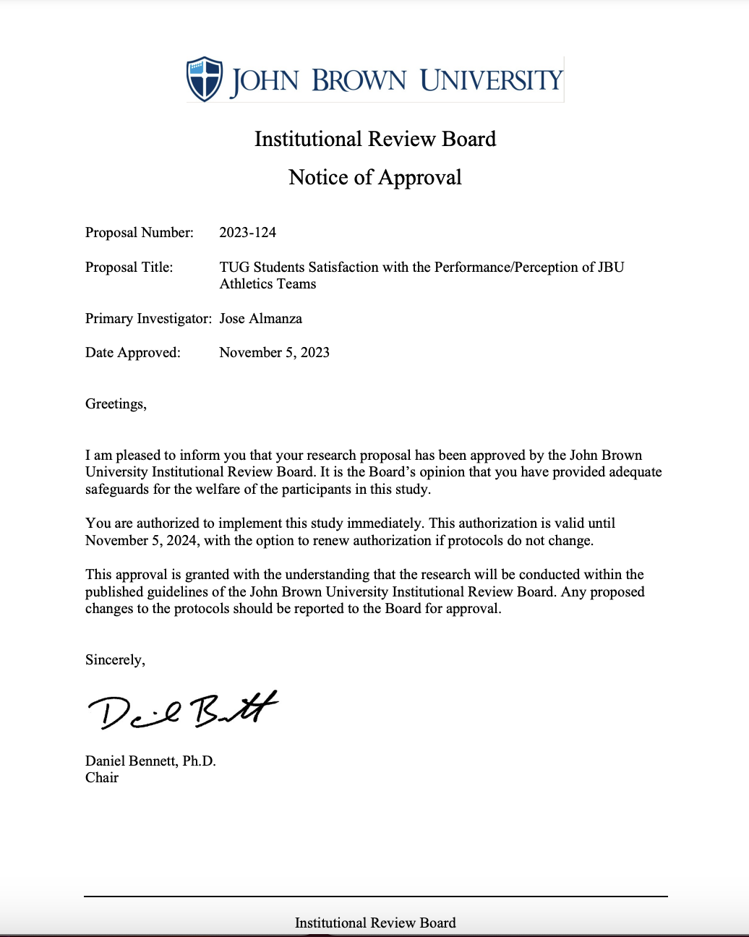

Figure 2
Research Instrument

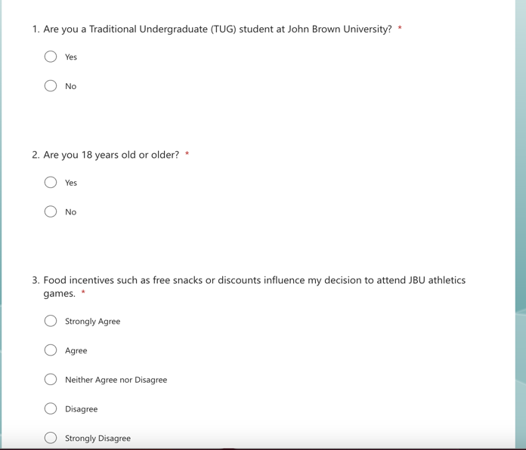
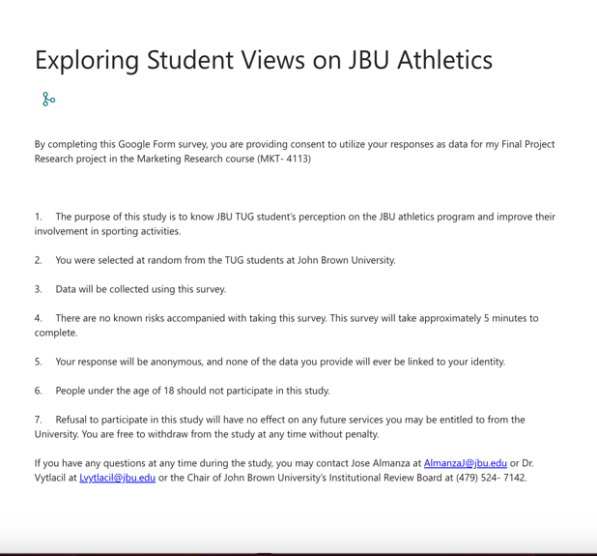

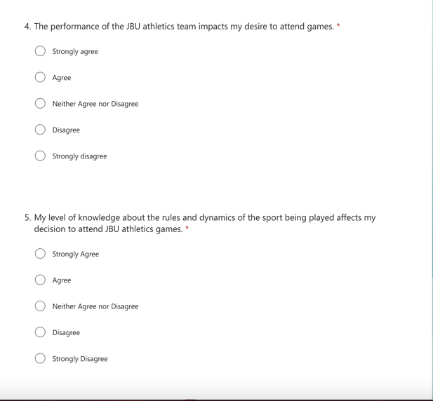

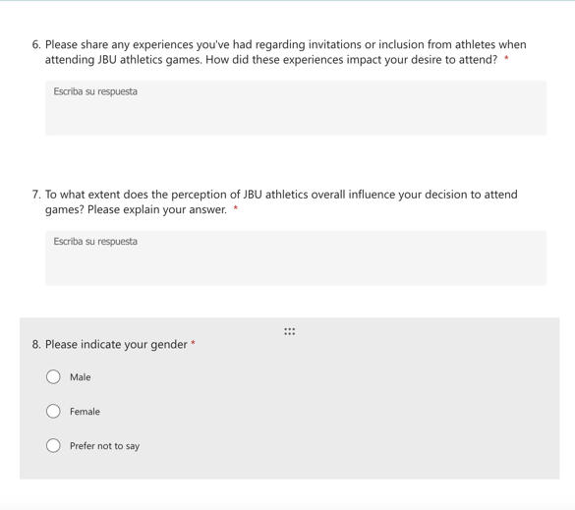

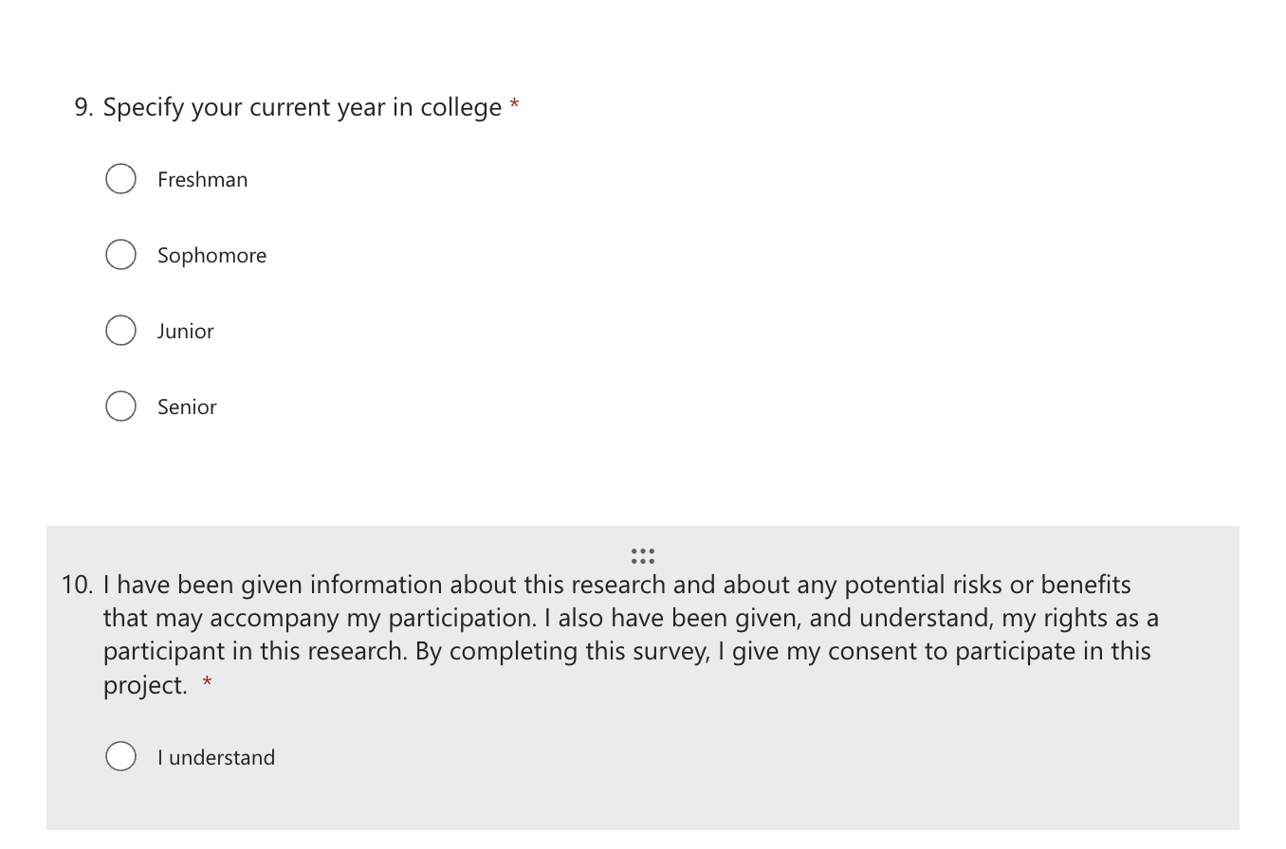

Figure 3
Invitational Email

